**LEBANESE AMERICAN UNIVERSITY**

**USAID – HIGHER EDUCATION SCHOLARSHIP PROGRAM**

**HES - Volunteering Program Verification Form**

This form is to be used to document volunteering hours. If a student volunteers for multiple organizations, a separate form must be used for each organization. **This form must be turned in by the 28th of each month, the latest.**

I certify that the scholar Serine Flity completed a total of 5 hours of service at InnovaThrive.

The hours were completed hours as per the below:

Hours # 0 (date) _2/12 – 6/12_ (initials of supervisor) __A.K.___

Hours # 0 (date) _9/12 – 13/12_ (initials of supervisor) __A.K.___

Hours # 0 date) _16/12 – 20/12 (initials of supervisor) __A.K.___

Hours # 5 date) _23/12 - 27/12 (initials of supervisor) __A.K.___

Brief description of the activities the scholar performed or participated in:

A research paper about Blockchain for Securing Public Health Data . The research explores the use of blockchain technology to enhance public health data management by implementing distributed ledger systems and cryptographic protocols, enabling secure data sharing during health crises, and facilitating accurate tracking of vaccinations and treatments. While offering advantages like increased trust and data security, it also addresses challenges such as high implementation costs and the need for compliance with global health standards. Future research directions include personalized healthcare information management and improving interoperability with existing health infrastructures.

Written feedback about the scholar’s performance:

Serine shows a solid understanding of blockchain’s role in public health data management, analyzing both its advantages and challenges. Her ability to explore future research directions demonstrates forward-thinking and a strong grasp of the technology.

Please rate the overall performance of the scholar at your organization:

|  |  |  |  |
| --- | --- | --- | --- |
|  | Mastery (5) | Proficient (3) | Emerging (1) |
| **Problem solver** | X |  |  |
| **Engaged & Committed** | X |  |  |
| **Open-minded & multicultural** | X |  |  |

Signature

& stamp

__________________________

_

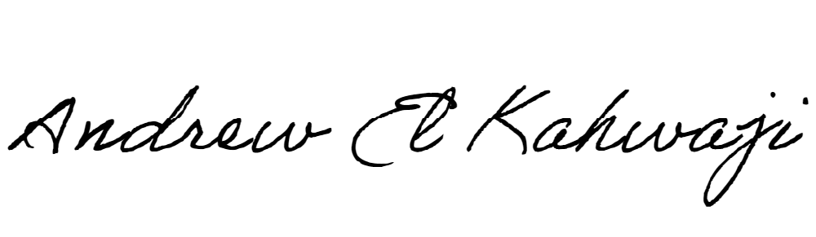

Printed Name _Andrew El Kahwaji_

Date __26/12/2024___

Email __andrew.lifesculptor.coo@gmail.com __

Phone __+961 71 914 378__